Lab 1 Worksheet Plate Tectonics Spring 2018
Name ______ (-2 points if missing)
Date _______
Use your textbook, lab and lecture PowerPoints, and internet as needed to answer all questions in each of the 2 parts. Please explain everything in your own phrases and sentences.
Part 1 Scientific Method
- In your own words, explain each of the basic steps of the scientific process.

- What is empirical data? Identify an example of something about Earth that we know because of empirical data.

- What is the difference between a theory and a hypothesis?

There has been very much in the news in recent years about increasing CO2 levels, and global warming. Using the Keeling Curve website (https://scripps.ucsd.edu/programs/keelingcurve/), address the following.
- Explain briefly the history of the Keeling Curve.

- Explain how this is empirical data.

- Describe the CO2 trends from 800,000 years ago.

- How is the Keeling Curve an example of the scientific method?

Part 2 Plate Tectonics
- Identify the 4 major points Wegener used to hypothesize the existence of Pangea.

- The Pacific plate is moving at an average of 5 cm per year, but this has changed over time. Use the following schematic to calculate the average rate of movement from the southeastern most dot on Hawaii (Kilauea) to:
  - Laysan

  - Kauai

  - Kure

  - Oahu

*divide the number of km by number of millions of years (Ma after the island name), then multiply by 0.1 for conversion to cm/year

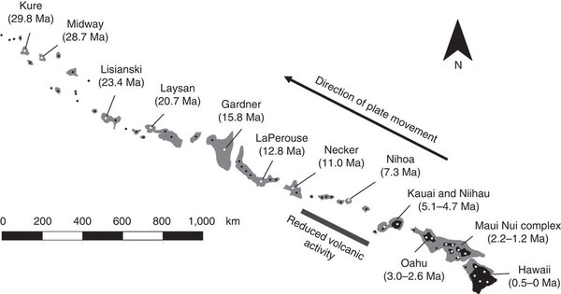

- Use the following map and the map on slide 6 in the Lab PowerPoint to answer the following questions.
  - What type of boundary is between plates G and I?

  - What is the name of the plate marked F?

  - Which plate is the Indo-Australian plate?

  - Around which ocean is the largest concentrations of earthquakes and subduction zones?

  - If you want to go to the Cocos Plate, what part of the Americas would be a good place to go?

  - The Nazca plate shares a convergent boundary with which continent?

  - The Nazca plate shares a divergent boundary with which plate?

  - What type of arrow should be found between plates M and B, towards each other or away from each other?

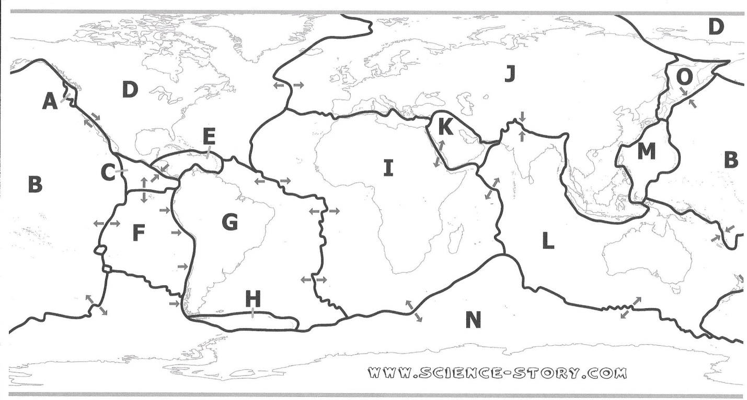

- Using the following map, answer the following questions. The arrows indicate relative rate of movement, and direction of movement.
  - What is the fastest rate of spreading shown on this map?

  - What is the slowest rate of convergence on this map?

  - How fast is India converging on Asia?

  - Besides India, what plates are converging on Europe and Asia?

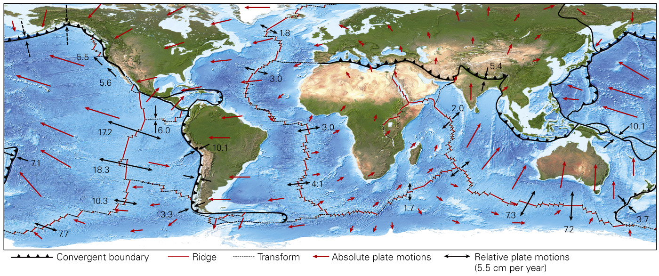
- Using the following diagrams, answer the following questions. The colored areas are normal polarity, and the white areas are reverse polarity.
  - Which of these three locations has the fastest rate of spread?

  - What was the magnetic polarity 3.5 million years ago?

  - Explain why there is more red shown for the Pacific Ocean (bottom)?

Source: Tarbuck, E., Lutgens, F., and Pinzke, K. (2012). Applications and Investigations in Earth Science 7th ed. Pg. 149-150 Pearson, Boston

- Which of the following diagrams shows a divergent boundary?
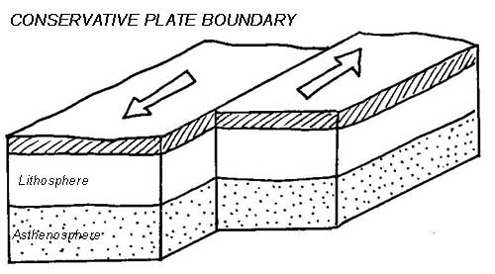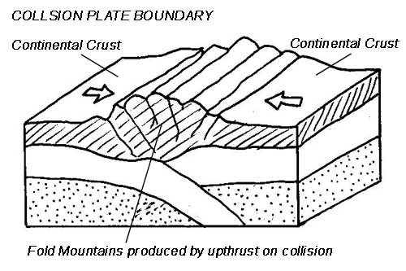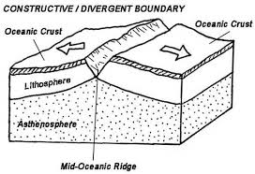
Diagram 1 Diagram 2 Diagram 3

- Explain the difference between the three types of plate boundaries.

- What type of boundary explains the presence of the Cascade Volcanic Arc in Washington, Oregon, and Northern California?

- What type of fault is the San Andreas fault?

- Which type of crust will go down at a subduction zone?

- Where are most of the transform faults found?

- Which plate boundary type will produce a volcanic arc?

- Explain the difference between a volcanic arc and an island arc.

- Identify a mountain belt that is an example continent-continent collision.

- The Benioff zone marks the locations of what?

- Provide an example of one volcanic arc, one volcanic island arc, and one hotspot not already mentioned in the PowerPoint lecture.

